**Assignment 1: The Solving Problem Process.**

**Objective: Automated Pet Feeder System**

**Background: Automated Pet Feeder System**

A local animal shelter is looking for a low-cost, programmable automated pet feeder that can:

1. Dispense food for cats and dogs at scheduled times.
2. Monitor whether food has been consumed or the amount of food that has been consumed.
3. Alert staff if there’s an issue (e.g., no food dispensed, food not eaten).

They want a solution that could eventually be implemented using low-cost components (like a servo motor and sensors), but your task is to design and simulate the logic and behavior of the system first.

1. **Step 1: Understand and Define the Problem (Analyse)**
2. **Clear Problem Statement**

Programable pet feeder based on scheduled time, feeding time, and bowl status and food bin status.

1. **Assumptions and limitations**
2. The same food is provided for cats and dogs, but the animals are kept separately.
3. Animals have free access to the machine throughout the day.
4. The user will also be able to set the schedule time and also adjust the real time clock if needed.
5. The system will be able to alert the user if the food bin is empty and if there was no food consumption in the following minutes after the bowl was fulfilled.
6. The bowl portion mass, is based on the number of seconds the servo feeder motor is on. Thus, the system can be used to feed one or more animals at time.
7. **Inputs and outputs**

Inputs: Scheduled times, feeding time, real-time clock, food bin pressure sensor and bowl pressure sensor.

Outputs: Feed screw motor and warning red light.

1. **Block diagram of the System**

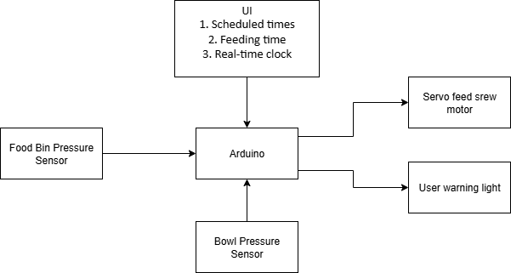

**GitHub repository link**

The link for my repository is show bellow

<https://github.com/KennySousa224/pet-feeder-project>

**References**

* draw.io. (n.d.). *diagrams.net*. Retrieved August 17, 2025, from <https://app.diagrams.net/>